Cloud Storage (S3) & Local Version Control (Git)

LAB 1 – CREATE YOUR FIRST AMAZON S3 BUCKET

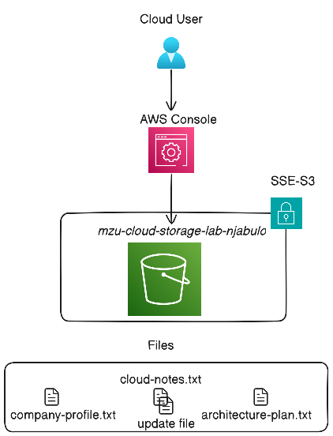

Task 1 Create Backet S3
Name
- mzu-cloud-storage-lab-njabulo
AWS Region
- US East (N. Virginia) us-east-1
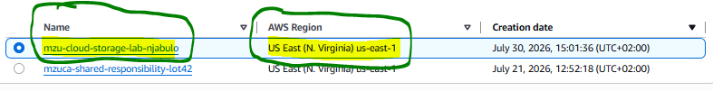

Block Access
- Enable
- Reason Business data should not be publicly accessible
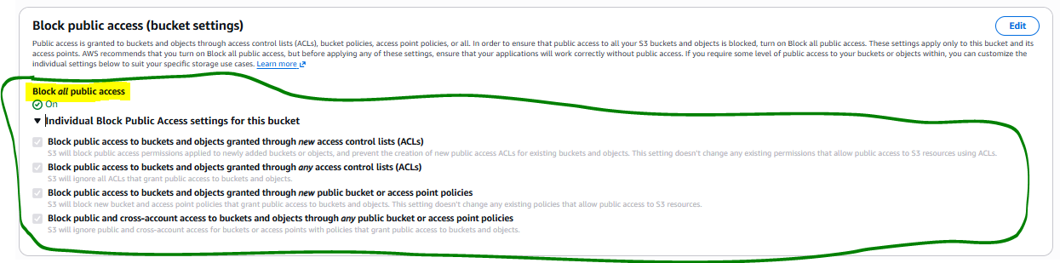

Bucket Versioning
- Enable
- Reason: Allows recovery of previous object versions
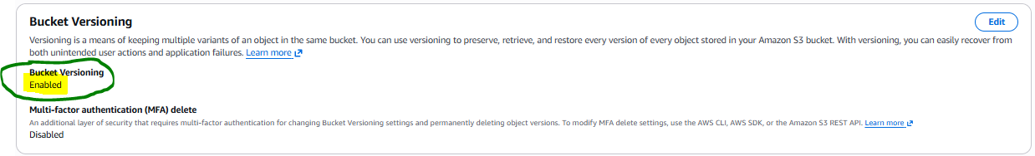

Encryption
- Enable: Server-side encryption
- Choose: SSE-S3
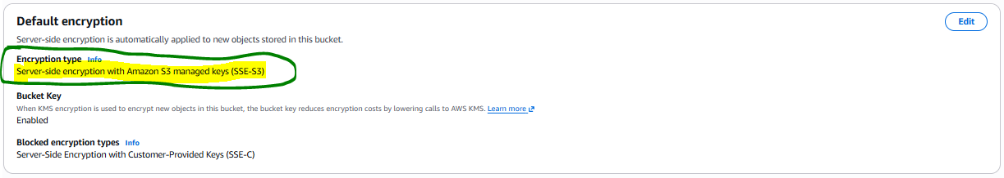

Upload & Manage Objects
Task1
Create
- company-profile.txt
- cloud-notes.txt
- architecture-plan.txt
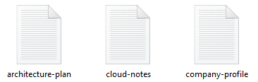

Task 2
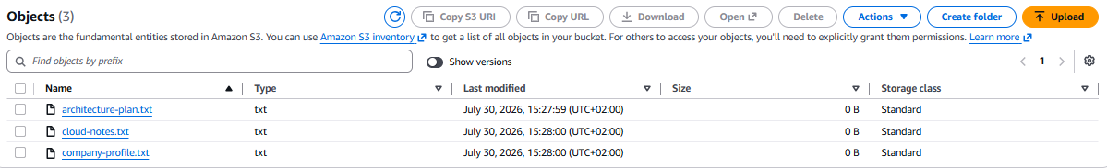

Upload

Task 3
Explore Object Information
Example
- cloud-notes.txt
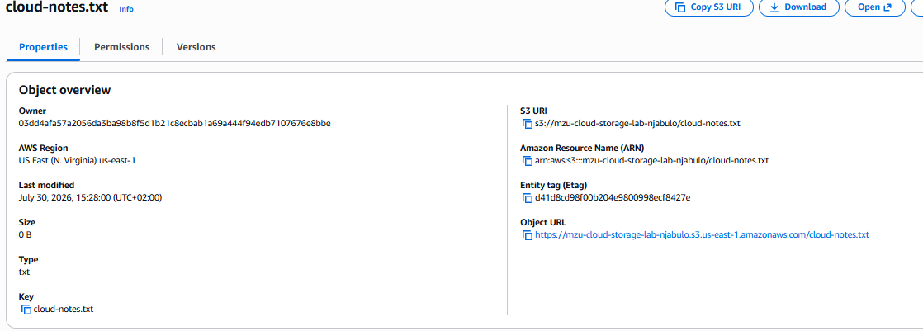
Storage Class
Encryption Status

Lab 3 - TEST S3 VERSIONING
Task 1
Modify a file
- cloud-notes.txt
- blank notes
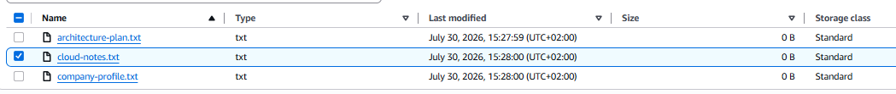

Updated
- AWS Cloud Advanced Notes
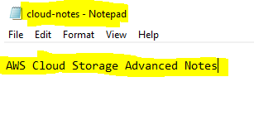

Task 2
Upload Updated File
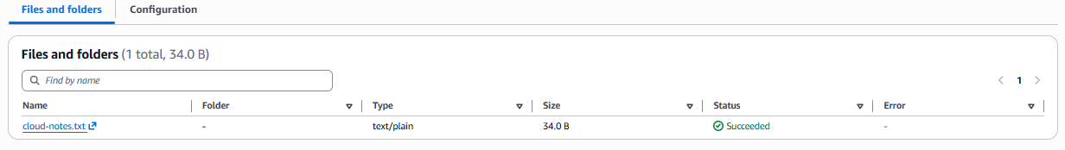
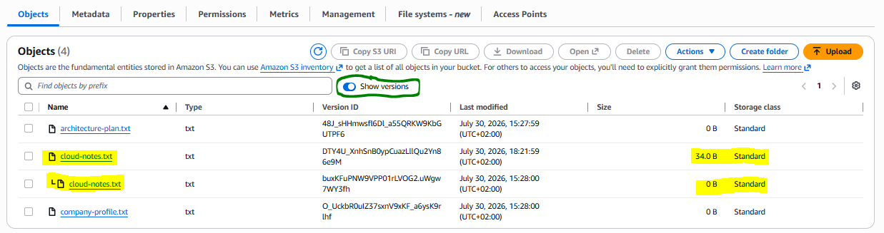
Task 3
View Versions

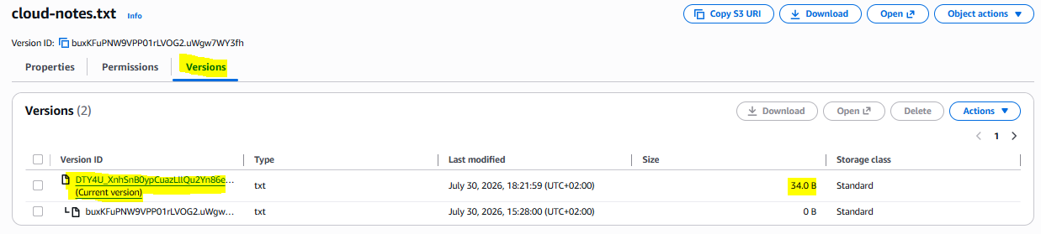

LAB 4 - INTRODUCTION TO GIT
Scenario
You are a cloud engineer managing infrastructure code.
You need a system to track changes.
Prerequisites
Install:
Git
Verify:
- git --version
Expected:
git version 2.55.0
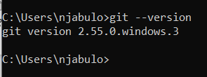

TASK 1 — Create Project Folder
Create:
cloud-storage-project
- mkdir cloud-storage-project

Navigate:
- cd cloud-storage-project

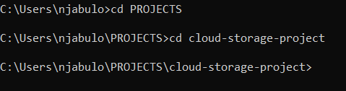
TASK 2 — Initialize Git Repository
Run:
git init
Expected:
Initialized empty Git repository
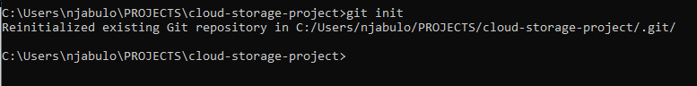

TASK 3 — Create Documentation File
Create:
s3-architecture.md
Add:
# Amazon S3 Architecture
S3 is an object storage service.

TASK 4 — Check Status
Run:
- git status
Observe:
Git detects your new file.
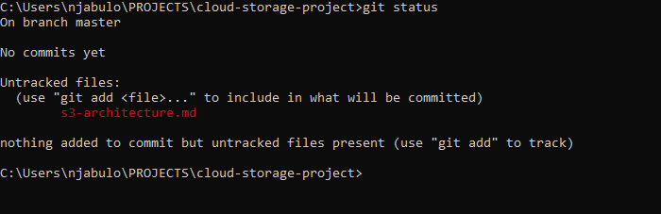

LAB 5 — COMMIT YOUR FIRST CLOUD PROJECT

TASK 1 — Add File
Command:
- git add s3-architecture.md
- git status
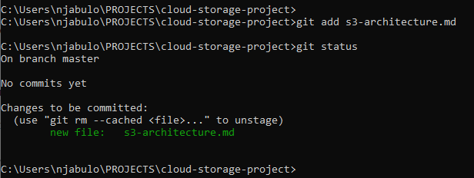

TASK 2 — Commit Changes
Command:
- git commit -m "Added S3 architecture documentation"
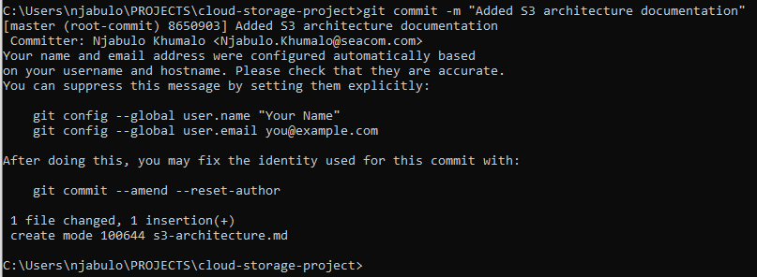
TASK 3 — View History
Command:
- git log
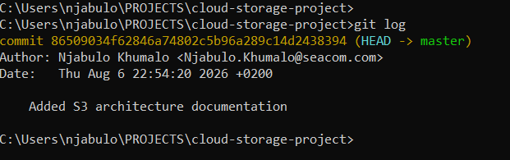Learning Outcome
You have created your first tracked cloud engineering project.

LAB 6 — CREATE CLOUD
ENGINEERING REPOSITORY
Scenario
Your team wants documentation stored centrally.
You will create a GitHub repository.
TASK 1
Create repository:
Example name:
- mzuca-cloud-storage-lab-bhakede
TASK 2
Connect Local Repository
Command:
- git remote add origin YOUR_REPOSITORY_URL
- git remote add origin https://github.com/iamnjebs/mzuca-cloud-storage-lab-bhakede.git

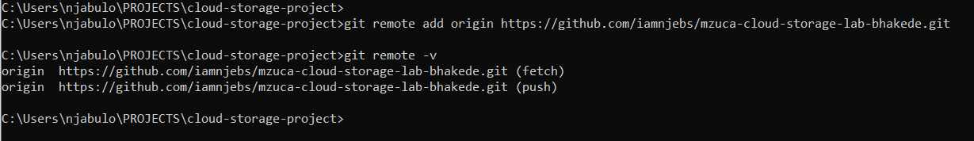

TASK 3
Push Code
Commands:
git branch -M main
git push -u origin main
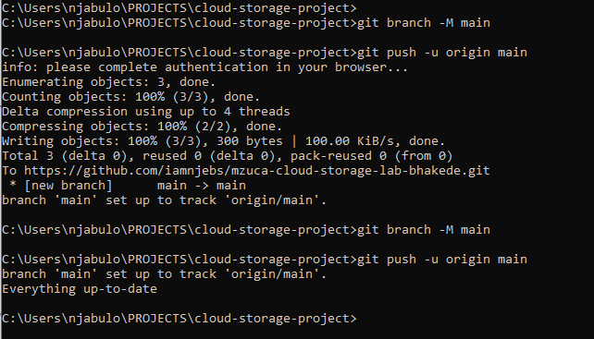

LAB CHECKPOINT
Confirm:
☐ Repository created
☐ Code pushed successfully
☐ Files visible online
FINAL ARCHITECTURE CHALLENGE
Design A Cloud Storage Solution
Scenario:
A healthcare company needs to store patient documents.
Requirements:
• Secure storage
• Data protection
• Access control
• Recovery capability
• Change tracking
Student Architecture Decision
Choose:
Storage
Amazon S3
Why?
Security Controls
Choose:
☐ IAM
☐ Encryption
☐ Versioning
☐ Logging
Explain:
Git Usage
How will Git help?
BONUS CHALLENGE — CLOUD
ARCHITECT THINKING
Design this workflow:
Developer
↓
Git Repository
↓
Automation Pipeline
↓
AWS S3
↓
End Users
Explain:
How does this improve:
1. Security?
2. Reliability?
3. Governance?
LAB COMPLETION CHECKLIST
Student Name:
Date:
Completed:
☐ S3 Bucket Created

